5.2 Project Tracker, Velocity and Burndown Chart

Project Tracker
Sprint | Total Story Points | Duration | Sprint Start Date | Sprint End Date (Planned) | Story Points Completed | Sprint Release Date (Actual)
Sprint-1 | 10 | 3 Days | 29 Sep 2026 | 01 Oct 2026 | 10 | 01 Oct 2026
Sprint-2 | 10 | 2 Days | 02 Oct 2026 | 03 Oct 2026 | 10 | 03 Oct 2026

Velocity
Total story points = 20.
Total project duration = 5 days.
Average velocity = 20 ÷ 5 = 4 story points/day.

Burndown Chart
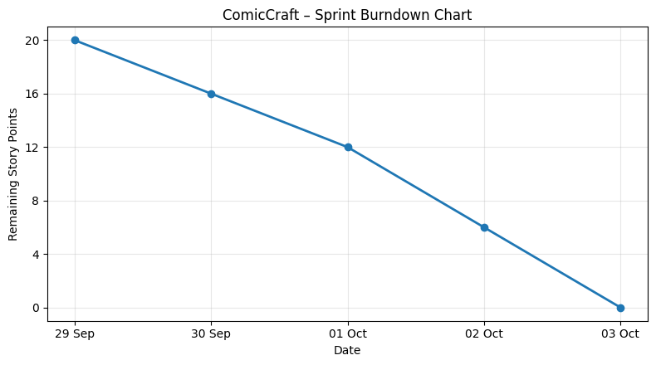
ComicCraft Sprint Burndown Chart

Team Responsibilities
Team Member | Planned Responsibility
Yuvasri | Story generation, backend integration and testing
Vishrutha | AI/image generation and PDF export
Krishnapriya | Frontend, FastAPI integration and documentation
Dharshini | Frontend, comic preview and testing
Subasri | Project coordination, user input module and final integration

